USER MANUAL

TERA
2-Bay Giga NAS Enclosure
Model：ME580GN-S
3.5” SATA RAID to
10/100/1000Mbps LAN
USB2.0
USB Host

FCC COMPLIANCE STATEMENTS
This equipment has been tested and found to comply with the limits for a Class B digital device, pursuant to Part 15 of the FCC Rules. These limits are designed to provide reasonable protection against harmful interference in a residential installation. This equipment generates, uses and can radiate radio frequency energy and, if not installed and used in accordance with the instructions, there is no guarantee that interference will not occur in a particular installation. If this equipment does cause harmful interference to equipment off and on the user is encouraged to try to correct the interference by one or more of the following measures :
Reorient or relocate the receiving antenna.
Increase the Distance between the equipment and receiver.
Connect the equipment into an outlet on a circuit different from that to which the receiver is connected.
Consult the dealer or an experienced radio/TV technician for help.
TRADEMARKS
MS-DOS, Windows, Windows 2000/2003/XP/Vista/Linux/Unix are trademarks of Microsoft Corporation. Macintosh and Mac are trademarks of Apple Computer
All of the third-party brands and names are the property of their respective owners.
Safety Warning
Please read this user manual carefully before using this product.
1. Always unplug the power cord before assemble Hard Drive.
2. Do not use different voltage rating power. It will damage this product.
3. Keep this equipment away from humidity or any type of moisture.
4. Do not drop or shack the device.
5. Do not press or put any weight on this device.
6. Do not use any alcohol, thinner or benzene to clean this device.
7. Please be careful while you plug the power adapter.

Table of Content

1. Introduction 5
2. Main Features 5
3. Product Overview 5
3.1 Product Contents 5
3.2 Minimum System Requirements 5
3.3 Take a look at the ME-580GN-S 6
4. Starting to Assemble 6
5. Starting to Use the NAS 7
5.1 How to search the NAS from the Network 7
5.2 Format the Hard Drive at the first time 9
6. BASIC Quick-setup 10
7. Control Panel 10
7.1 User Management 10
7.2 Group Management 12
7.3 File and Printer 12
7.3.1 File Server 12
7.3.2 Share Management 13
7.3.3 Printer Server Setup 14
7.4 System Setting 20
7.4.1 LAN Setting 21
7.4.2 Time Setting 21
7.4.3 Turn Off Server 22
7.4.4 Information 22
7.4.5 Disk Usage 22
7.4.6 Error Notification 23
7.5 Network Service 25
7.5.1 DHCP Server 25
7.5.2 Bonjour 26
7.5.3 BT Download 27
7.5.4 Media Server 29
7.6 Maintenance 30
7.6.1 Disk Utility 30
7.6.2 RAID Setting 32
7.6.3 Firmware Upgrade 33
7.6.4 Save Configuration 34
7.6.5 Restore Configuration 34
7.6.6 Factory Reset 34
7.6.7 Software Update 35
7.7 Log File 36
8. How To Reset The Configuration Setting 37
9. How To Replace A Faulty Hard Drive 37
10. FAQ 38

- Introduction
TERA ME580GN-S, the 2-Bay 3.5” SATA Network Storage Enclosure enables you to share photos, music, videos and more over the network. This easy-to-use network storage enclosure is perfect for quickly sharing and managing your valuable data by your own way.

With high transferring Giga LAN performance and built-in NAS functions, ME580GN-S is a powerful data center. File sharing via FTP/SAMBA or BitTorrent download support , even simple data control via USB2.0 connection and the RAID function support … etc, ME-580GN-S features versatile capabilities to be your strong back-up anytime.

- Main Features

- Fits two 3.5” SATA drives (supports up to 2TB per HDD)
- Giga LAN , USB2.0 up to 480Mbps
- Rigid metal casing with superior heat dissipation capabilities
- Efficient FAN cooling airflow
- Key lock for HDD security
- Mirror panel with blue graphic luminous indication of device status
- RAID 0 (FAST), RAID 1 (SAFE), JBOD and Non-RAID
- FTP / SAMBA file sharing over the network
- Convenient Downloads with BitTorrent, HTTP, and FTP transfers
- USB printer server, iTunes Server, UPnP
- Supports DLNA certified digital media players
- Compatible for Windows, Mac OS, and Linux-based environments
- User-friendly web-base GUI

- Product Overview

3.1 Product Contents
ME580GN-S x 1、LAN Cable x 1、Power cord x 1、QIG x 1、Installation CD x 1、Screws Pack x 1

3.2 Minimum System Requirements
Windows® NT/2000/2003 server/XP x86 / XP 64 bit / Vista X86 / Vista 64 bit/Linux/Unix
233 MHz Pentium® II or above
64 MB RAM (128 MB recommended)
USB 1.1 Port (USB 2.0 recommended)
CD-ROM drive for installation
Mac® OS X 9 or above
128 MB RAM (256 MB recommended)
USB 1.1 Port (USB 2.0 recommended)
CD-ROM drive for installation

3.3 Take a look at the ME580GN-S
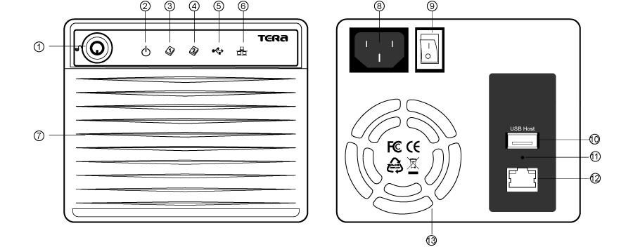
① Enclosure Lock
② Power LED Indicator
③ HDD1 LED Indicator
④ HDD2 LED Indicator
⑤ USB Mode LED Indicator
⑥ LAN Mode LED Indicator
⑦ Air Flow Gap
⑧ Power Socket
⑨ Power Switch
⑩ USB Host Connector
⑪ Reset button
⑫ LAN Connector (10/100/1000Mbps)
⑬ FAN Outlet

- Starting to Assemble

Install the hard drive
Step1. Open the enclosure front door.
Step2. Take out the hard drive tray manually
Step3. Combine the hard drive onto the tray with screws
Step4. Put the hard drive tray in the enclosure and close the door.

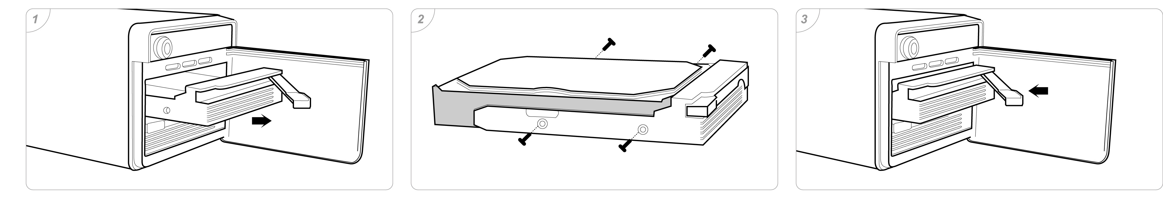
- Starting to Use the NAS
Before to start the ME580GN-S, please connect the ME580GN-S into the internet directly or through the networked router. Please make sure the LAN connection is ok. If you would like to attach the ME580GN-S to the computer, you need to setup it with the same domain as the ME-580GN-S. The default IP address of the ME580GN-S is 192.168.1.1.

5.1 How to search the NAS from the Network
Step1. Find “SetupUtil.exe” from CD and double click to setup.
Step2. “Network Storage Link –Setup wizard” will pop up. Click the setup to the search page.
Step3. You can find out the NAS from the dialog box.

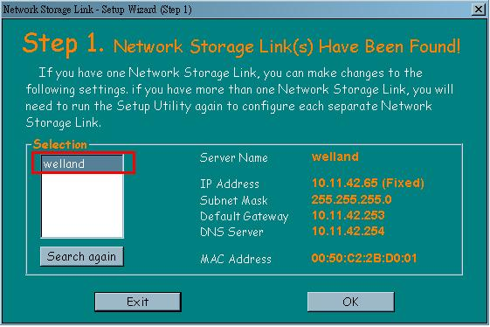

Step3. Double click the NAS that you find. You will be led to the NAS operation page. On this page you can start to use NAS function.

Default Username: admin
Default Password: admin

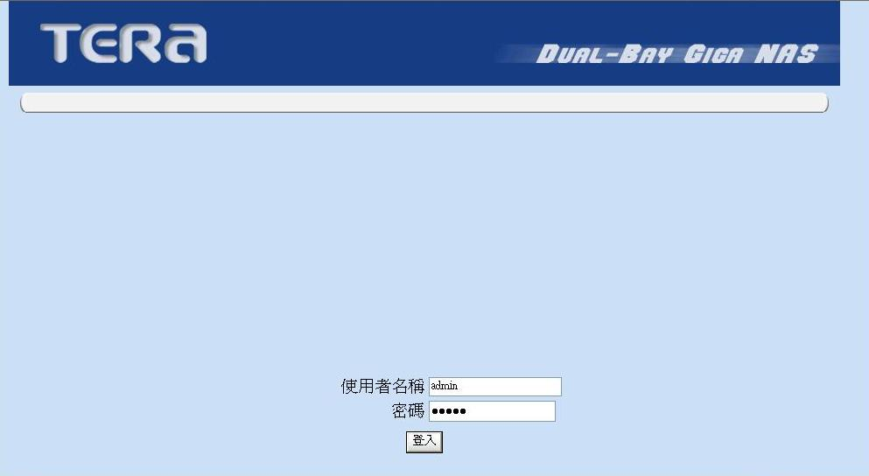

Step4. Click the OK button to enter the password and setup the Host name. Password is admin.
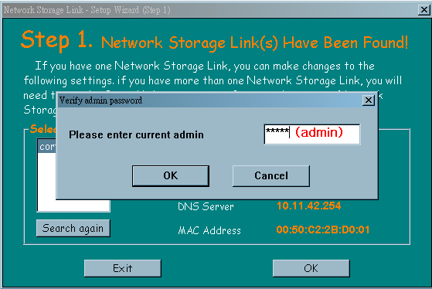

Step5. Here you can modify your Server Name and IP address automatically or manually. And then click the Next button to setup the Date and Time.
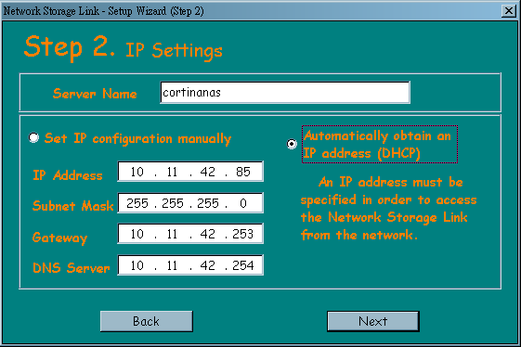

Step6. Setup the date and time, it will be auto updated from internet. If it’s correct , click Next.
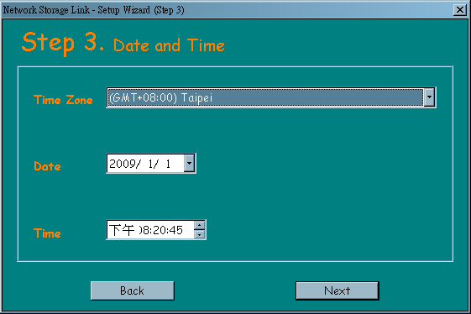

Step7. Click the Save button to confirm the previous configuration.
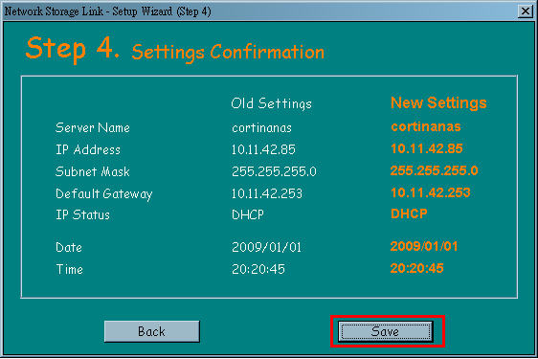

5.2 Format the Hard Drive for the first time
For the first time, you will need to execute the hard disk format to fit NAS system as individual disk from the Disk Utility. Or you can format the hard drives to be as RAID drives from the RAID Setting. The supported format are FAT32, NTFS, EXT2 and EXT3, but FAT32 is not supported in RAID mode. Please refers to the 6.6.1 Disk Utility or 6.2.2 RAID Setting for details.

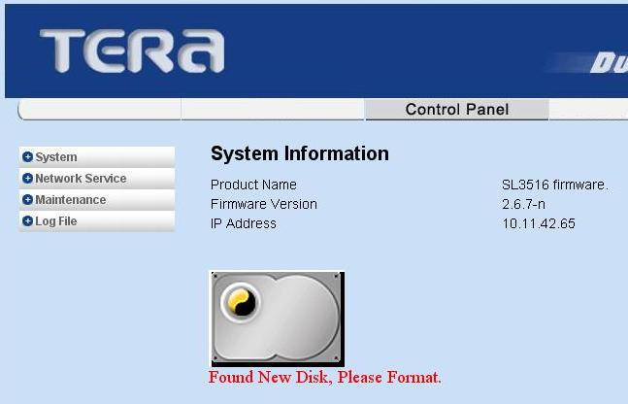

- Basic - Quick Setup
After login the ME580GN-S by web browser, there are 3 function icons : “Basic”, “Control Panel”, and “Personal Information” which including the related operation charts.
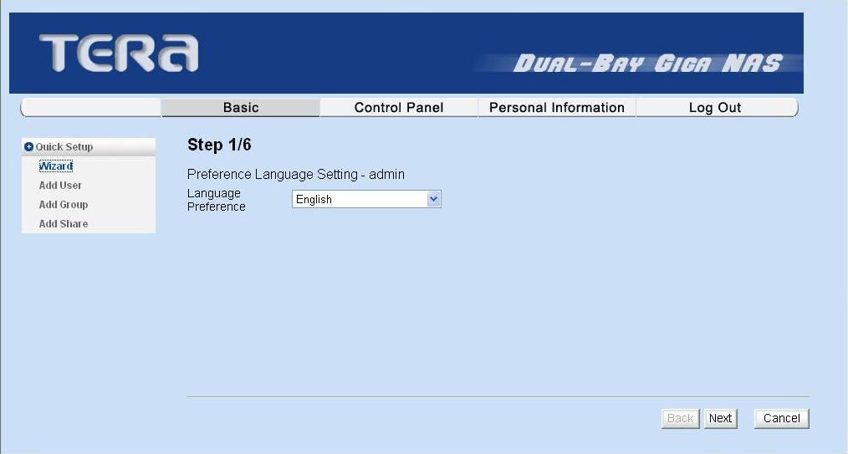

Wizard: To quickly modify the language of operation menu, host name, password, IP/DNS setting and Time Zone/NTP setting.
Add User (SAMBA) : To add user, select the Add User chapter for setting. Please refer to Users and Groups of Control Panel for more setting details.
Add Group (SAMBA) : To add group, select the Add Group chapter for setting. Please refer to Users and Groups of Control Panel for more setting details.
Add Share (SAMBA) : To add sharing folder, select the Add Share chapter for setting. Please refer to Share Management of File and Print of Control Panel for more setting details.

- Control Panel

7.1 User Management (SAMBA)
In User Management menu, it shows all existing users in the system. A new user can be created by filling out the form and click Save. Steps as below:

Step1. Enter the new user name and password and click Save.
Step2. (Optional) If needing to do description for the user, you can key in the message in the Description dialog.
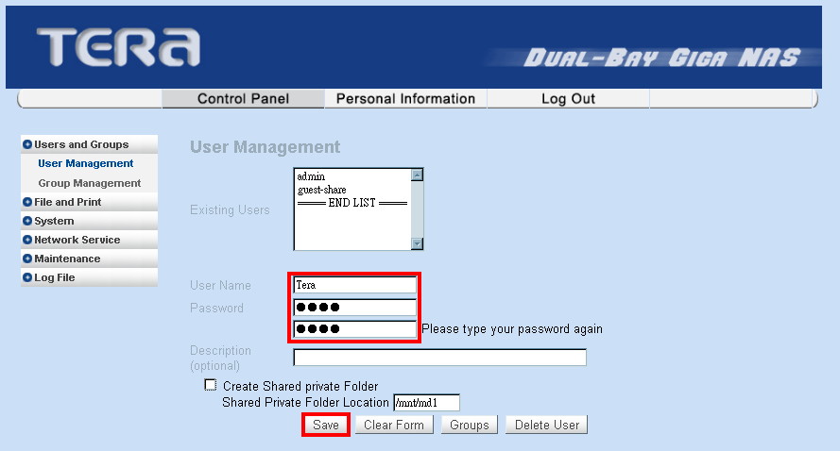
Step3. If creating a private folder for sharing, please mark the Create Shared Private Folder on
and then click Save. Then you will see this new folder as below.

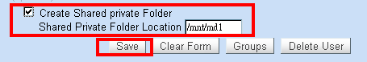

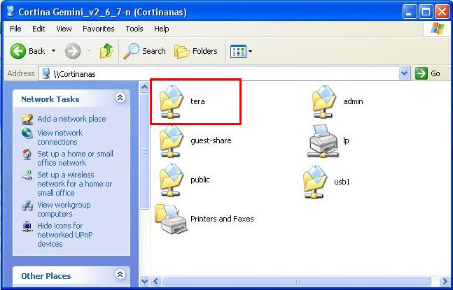
Step4. You can manage the user in the specific group. Choose the user from the Existing Users list and then click the Groups to manage.

7.2 Group Management (SAMBA)
In Group Management, it shows all existing groups in the system. A new group can be created by filling out the form and click Save. Select the existing group name and click Delete Group button to delete a specific group. Add or Remove users from an existing group can be done by highlighting the group name and click Save.

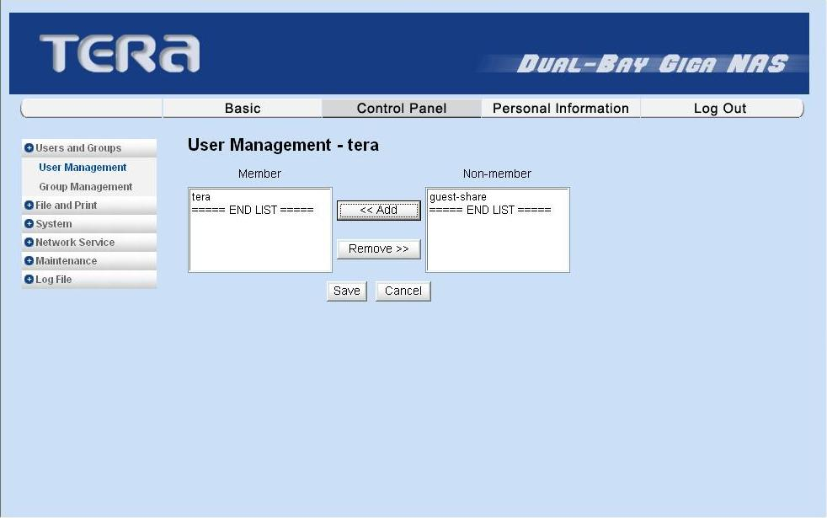

7.3 File and Printer
You can set up File server, Share Management, and Printer server under this icon.

7.3.1 File Server (FTP)

Character set : to choose the code of different language
Windows Setting:
Setup1. Set “Enable” to enable Microsoft Windows connection.
Setup2. Set Workgroup name for Windows client to access
Setup3. Define IP address of Windows Internet Name Server (Optional)
FTP Server Setting: In this section you can enable the FTP with the FTP port (default is 21). Or you can also enable it with TLS (Transport Layer Security). After finished the task, you can start to share the files through FTP server.

NFS Server Setting: If you disable this function, you will not find the files from the workgroup.

Guest Accessing Setting: If you disable this function, you will not find the guest-share folder from the workgroup through MY Network Spaces. You can manage the size of guest share folder.

7.3.2 Share Management (SAMBA)
It shows all existing shared names; “public” is the factory default shared name.
Step1. Key in the new name of the sharing folder. And then click the Save.
Step2. Click the folder from the Existing Shares list. Then click the Windows, FTP Access to setup the access authority.
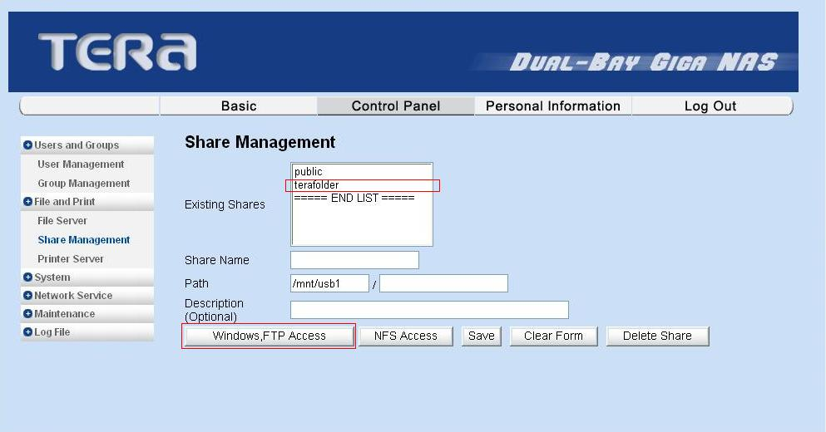

Step3. If needing to set the shared folder without access control, please choose the Grant access to all. And you can allow the user to Read Only or Writable.
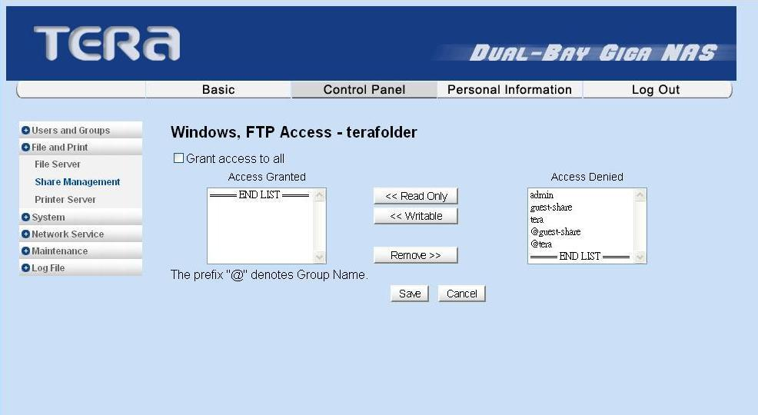

Step4. Click the folder from the Existing Shares list. Then click the NFS Access to set up the access authority.
Step5. If need to allow user of different IP address to access the folder without access control, please select the Grant access to all. You can allow the specific IP address that you added.
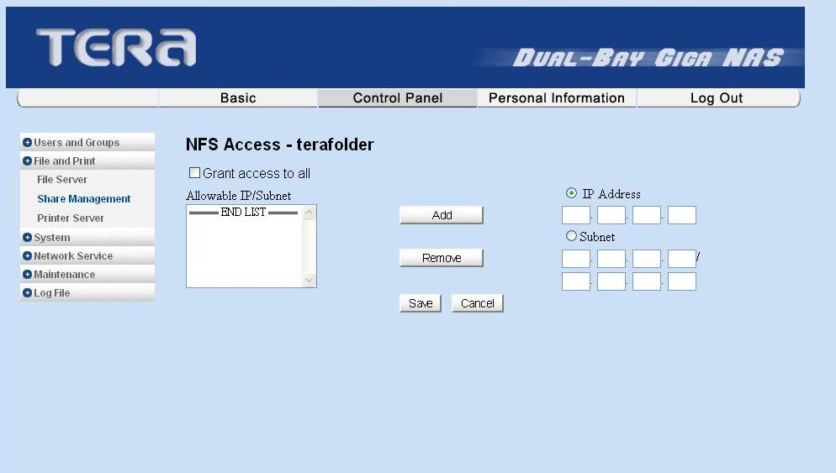

7.3.3 Printer Server Setup
Step1. Select Enable, Print Server function will be enabled.
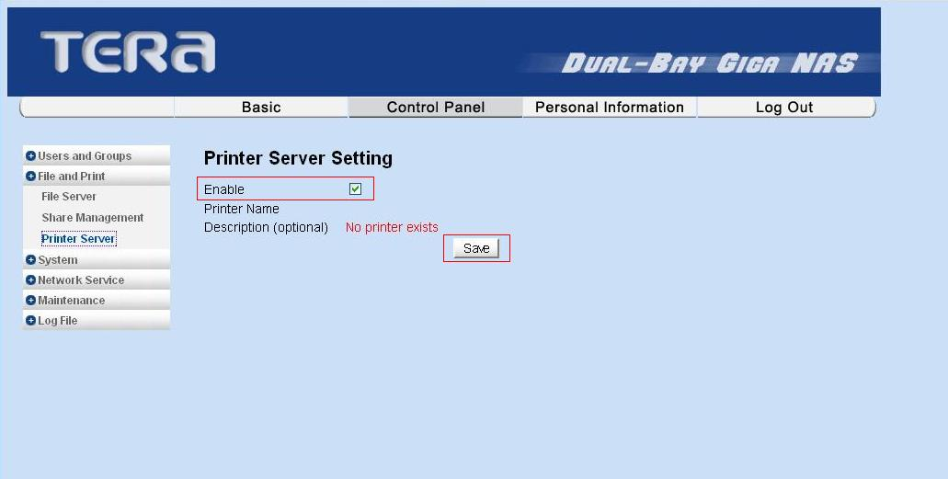

Step2. Click the Start and select the Printers and Faxes from the Start menu

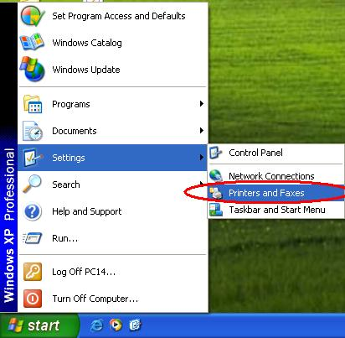

Step3. Click the Add a printer.
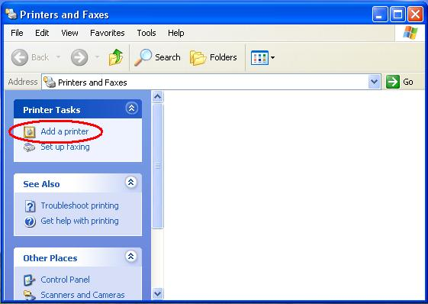

Step5. Click the Next.
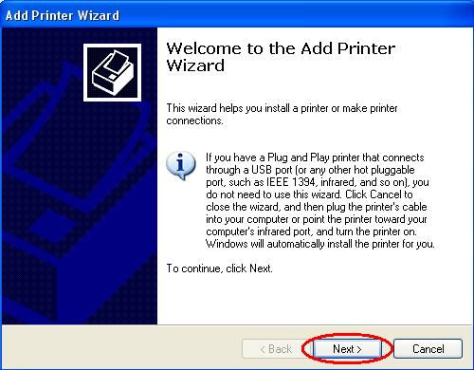

Step6. Choose the A network printer, or a printer attached to another computer and then click the Next.
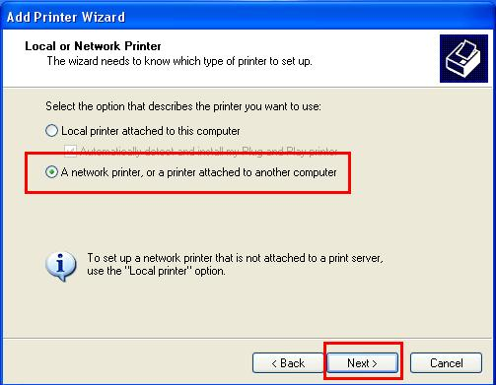

Step7. Choose Browse for a printer, and then click the Next.
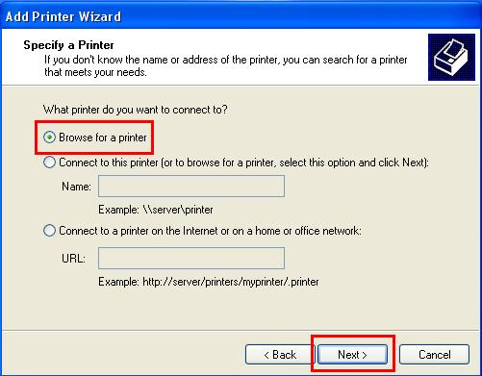

Step8. Double click the NAS, and click the lp then click the Next.

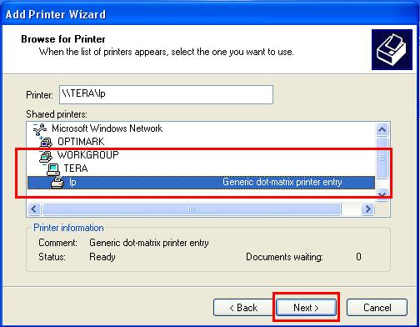

Step9. Click OK to the next step.
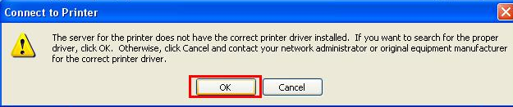
Step10. If the printer is not in the printer list, please click Have Disk to search the printer driver.
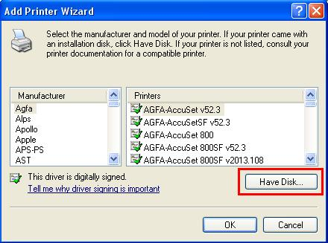

Step15. You need to find your printer driver in the printer driver CD.
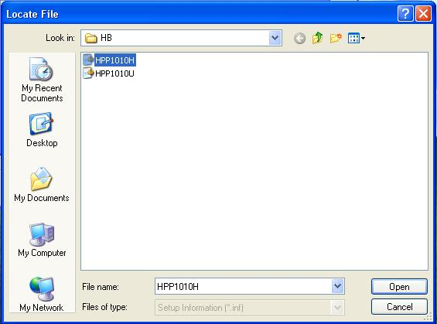

Step16. Select the printer driver of your printer model. Then click the Next.
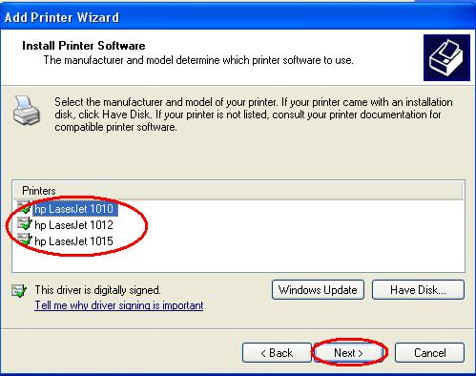

Step17. Click the OK to start the driver installation until it is completed.
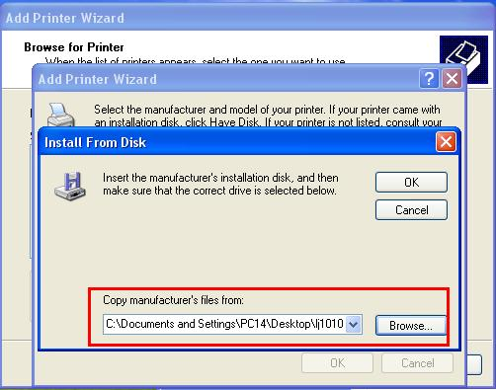

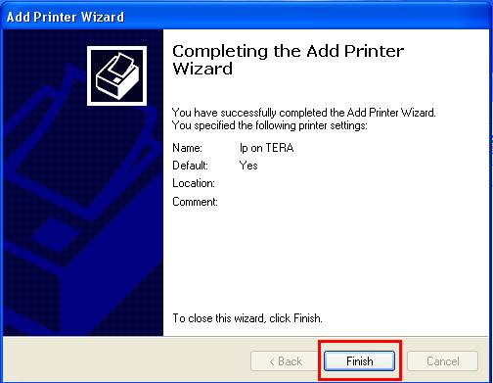

Step18. After installation, you can see your printer is installed in the Printer and Faxes.
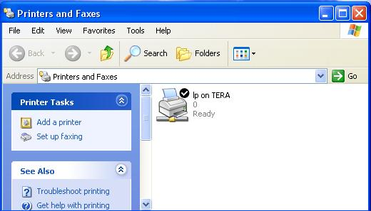

7.4 System Setting
Six sections are included in “System Setting”, they are “Network Setting”, “Time Setting”, ”Turn Off Server”, ”Information”, “Disk Usage”, and “Error Notification.

7.4.1 LAN Setting
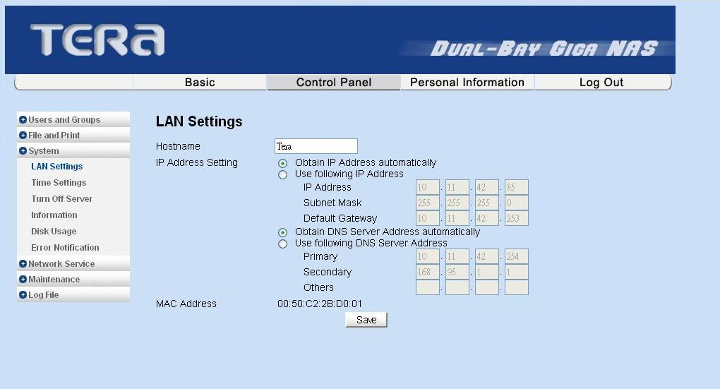
Host Name: You must assign a unique name for ME580GN-S as the identification of your local area network.
IP Address Setting:
- Obtain IP address automatically
The system obtains the IP address automatically via DHCP protocol if the local network has DHCP server available. The default IP address is 192.168.1.1, if it failed to get an IP address from DHCP server.
- Use Static IP address
Acquire a unique IP address, Subnet mask, and Default gateway Information from your network system administrator. Then fill in the information to the GUI.
- Obtain DNS Server address automatically
The system gets DNS server addresses from DHCP server if available
- Use static DNS server addresses
Specify DNS server address in the GUI.

7.4.2 Time Setting
- Set current Date, Time and Time zone.
- Specify NTP server if you want to get Date and Time from time server.
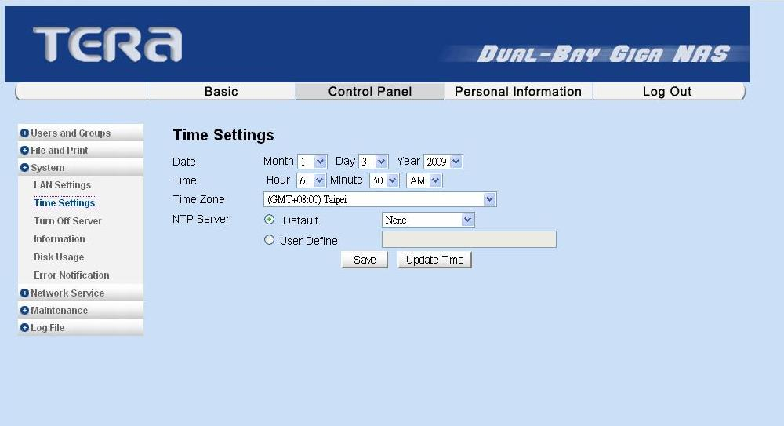

7.4.3 Turn Off Server
- To restart the server, click the “Restart”.
- To power off the server, click the “Shutdown”.

7.4.4 Information
Display system information, such as Product Name, Firmware version and IP Address.

7.4.5 Disk Usage
- Choose the Summery to see the Hard disk usage.
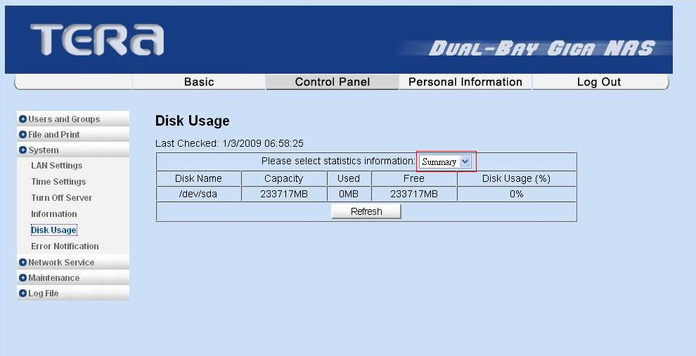
- Choose the User to see the user’s disk usage.
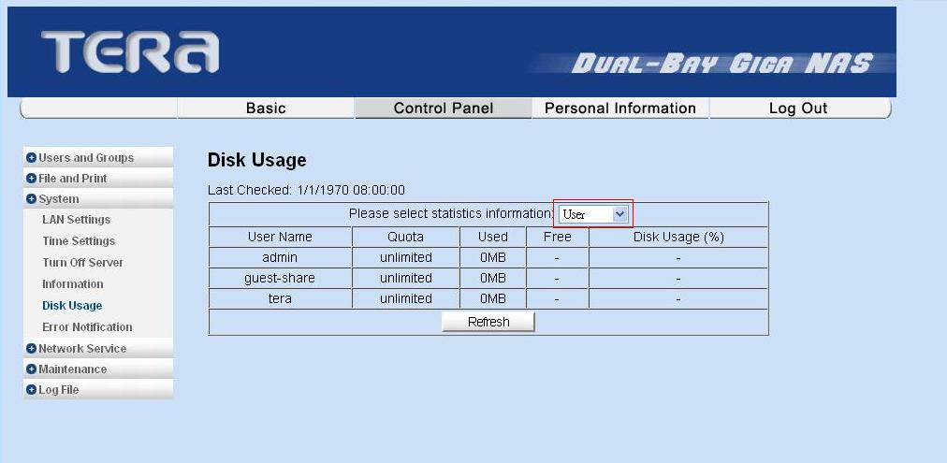

7.4.6 Error Notification
- Monitoring Services Setting:
Disk Usage: If the disk usage reaches 90%, the system will inform the administrator.
Windows File Sharing Server: If the SAMBA task occurs problem, the system will inform the administrator.
FTP Server: If the FTP Server task occurs problem, the system will inform the administrator.
DHCP Server: If the DHCP Server task has any problem, the system will inform the administrator this message
Check Interval: You can select the system informed interval to hourly or daily.

- Email Notification Setting:
Enable: Enable notification method by an email.
Error Handling Mail Server: Specify your email host name.
Error Handling Email Addresses: Specify administrator email address.
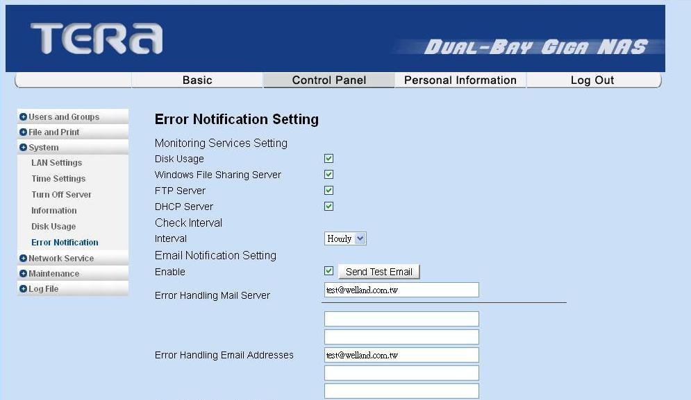

- Pop-Up Notification Setting:
Enable: Enable notification method by Windows pop-up messages.
Error Handling Pop-Up Machines: Specify administrator PC IP address
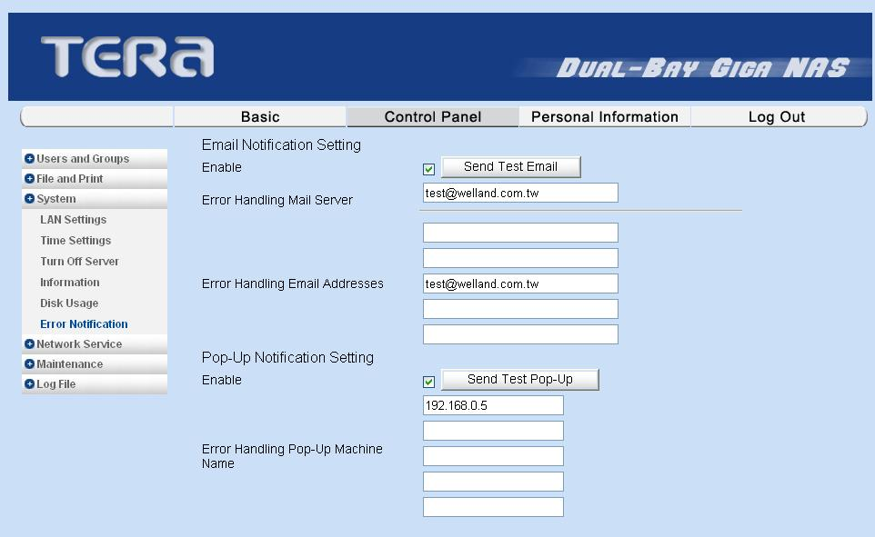

7.5 Network Service

7.5.1 DHCP Server
To enable DHCP Server, please take the following steps:
- If ME580GN-S fails to get an IP address from the external DHCP
Server, it can use the default IP address 192.168.1.1 and turn on its DHCP Server automatically.
- If ME580GN-S successes to get an IP address from the external DHCP Server, you should set the IP address to a static IP address before enabling DHCP Server.

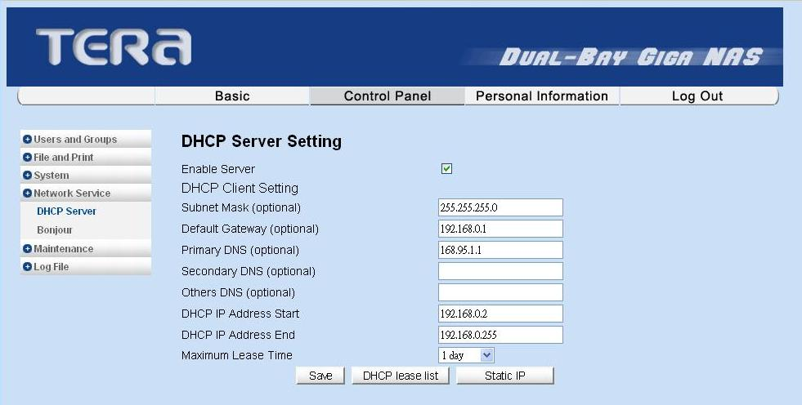

7.5.2 Bonjour
ME580GN-S supported Apple Bonjour protocol and Apple iTunes server.
- Check Enable box could enable Bonjour protocol.
- Check iTunes Enable box could enable iTunes server.
All of MP3 music files should be put in /public/music folder through samba or ftp protocol, then client pc can search ME580GN-S and play music within iTunes tool. The iTunes tool can be downloaded from Apple website.

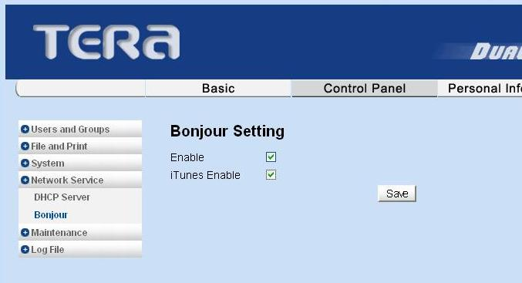

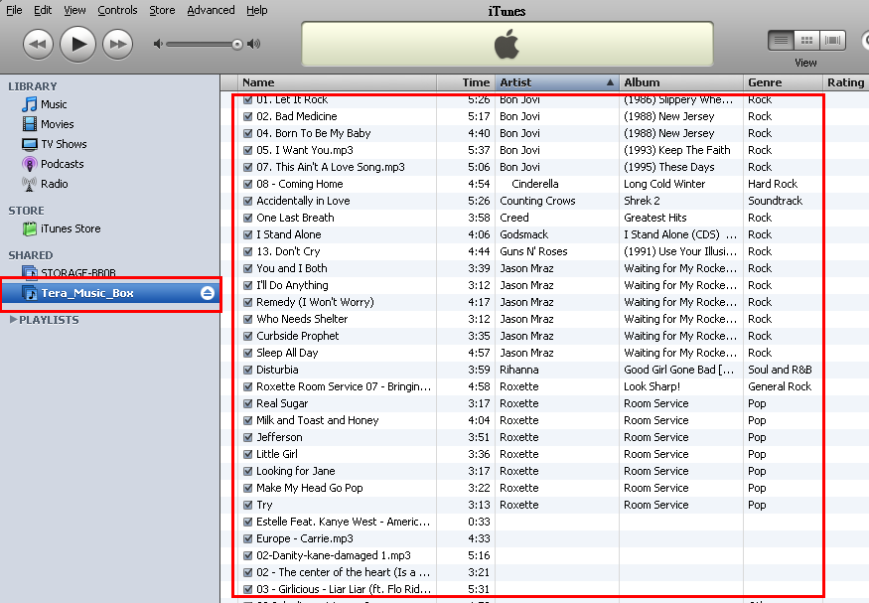

7.5.3 BT Download
Step1. Please refer to the 6.6.6 Software Update to install the BT application torrentflux-1.14.bz2. Find the application from the CD content.
Step2. After installing the application, you can find the TorrentFlux appear on the Network Service. You can enable the function.
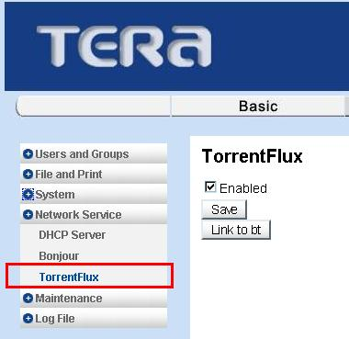

Step3. Click the “Link to bt” to the BT download page.
Username: admin
Password: admin
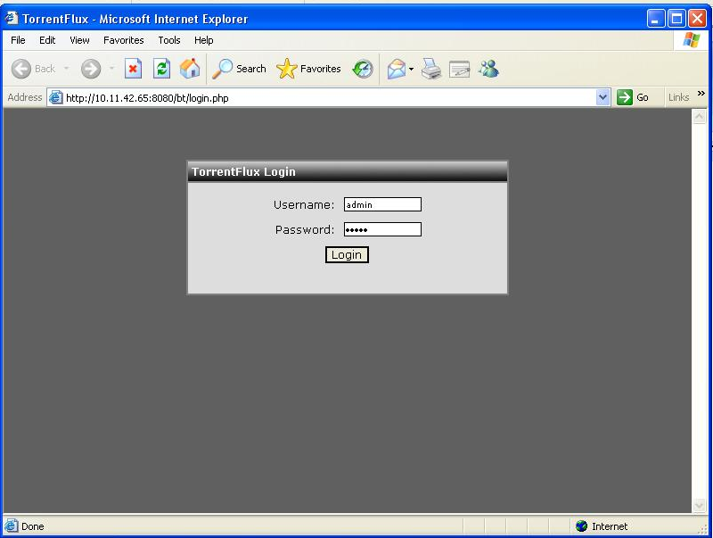
Step4. Click the Browse to select the Bit Torrent file. Then Click the upload after you selecting the file.
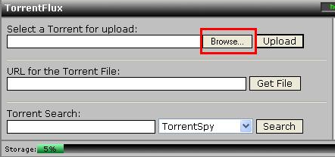

Step5. Click the icon to download. You also can view the downloading status from this
page.
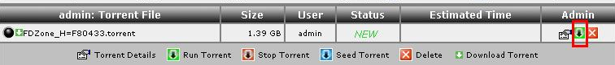
Step6. The download files will store at the Public/tf folder.
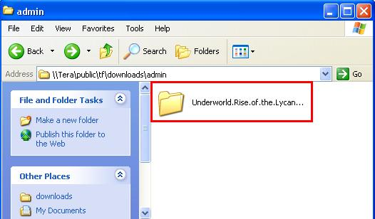

7.5.4 Media Server
Step1. Please refer to the 6.6.6 Software Update to install the BT application syabas-1.12.bz2. Find the application from the CD content.
Step2. After installing the application, you can find the Syaba appears on the Network Service. You can enable the function.
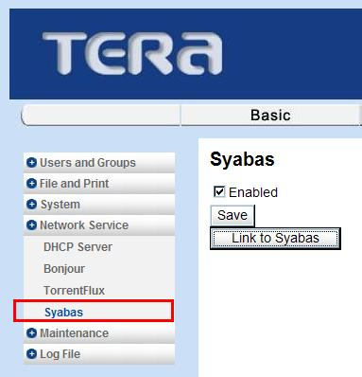

Step3. Click the “Link to Syabas” to the BT download page.
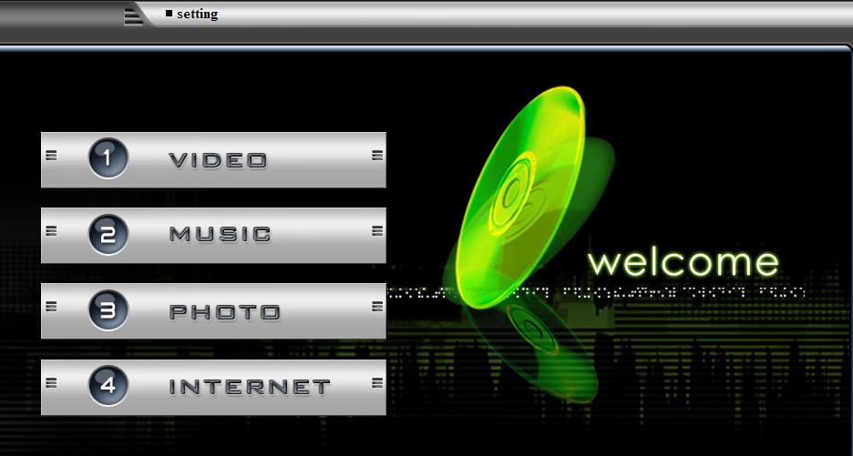
Step4. Before you starting play the media, you should put the media in the public/media folder as below. Put the music in the Audio folder. Put the picture in the Photo folder. Put the movie in the Video folder.
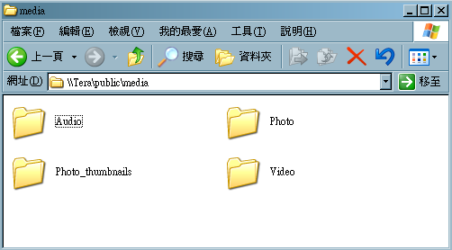

7.6 Maintenance
There are five sections are included in Maintenance. There are “Disk Utility”, “Firmware Upgrade”, “Save Configuration”, “Restore Configuration”, and “Factory Reset”.

7.6.1 Disk Utility
Disk utility shows device name, type of file system, total disk size, used disk size, volume mounted, and disk mount status of all disks. For new attached hard disk, you should format the HDD before any setting. To avoid the wrong press on the button, the system will acquire your confirmation before starting “Format” or “Scandisk” function.
- Encrypt Box
ME580GN-S supports 128 bits loop-AES encryption of EXT2 file system. If you want to turn on this function, you should input 20 characters password and format disk again.
- Format Button
This is used to format the specified disk. ME580GN-S supports four types of file system: “EXT2”, “EXT3”, “NTFS” and “FAT32”.
- Scan Button
This is used to check the disk integrity.
- Detail Button
If the hard disk supports S.M.A.R.T, it will report the disk health status.
- Disk spin down time
Specify your disk spin down time without access the hard disk.
- If you plug-in an USB pen drive or external disk, it will mount this disk to /mnt/usb3 and share folder name “usb3” on Samba or FTP.

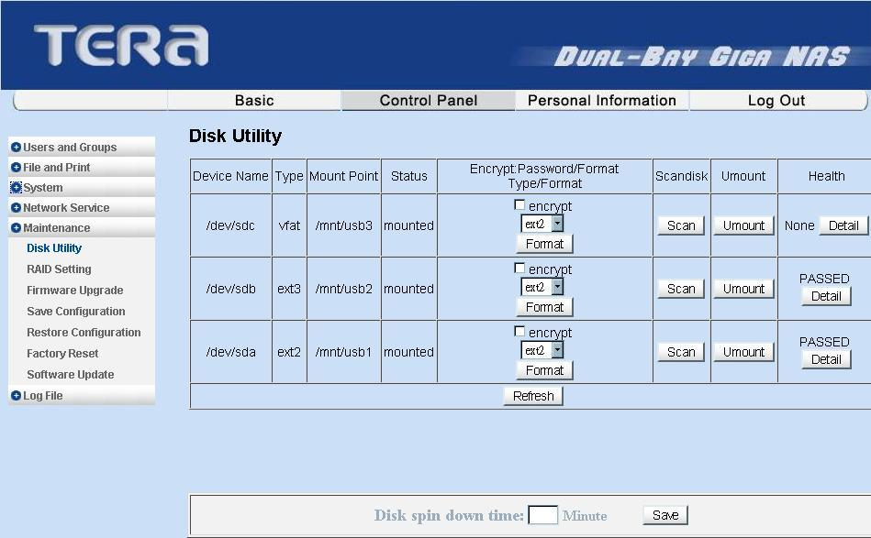

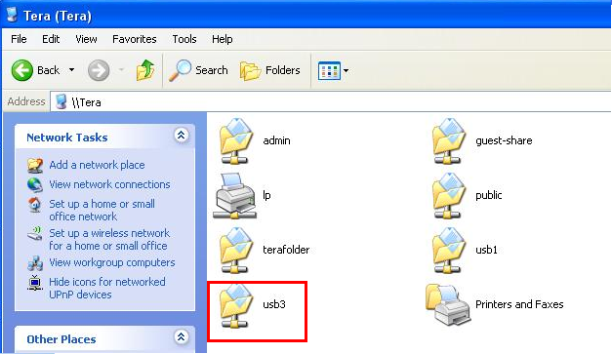

7.6.2 RAID Setting
ME580GN-S supports RAID type 0, 1 and JBOD that depends on hard drive amount. If ME580GN-S only plugs in one hard drive, the “RAID Type” box only shows “None” item. If ME580GN-S plugs in two hard drives, the “RAID Type” box will show “None”, “raid0”, “raid1” and “Linear” items.

Step1. Choose the RAID mode and hard drive format, then click Create raid System.
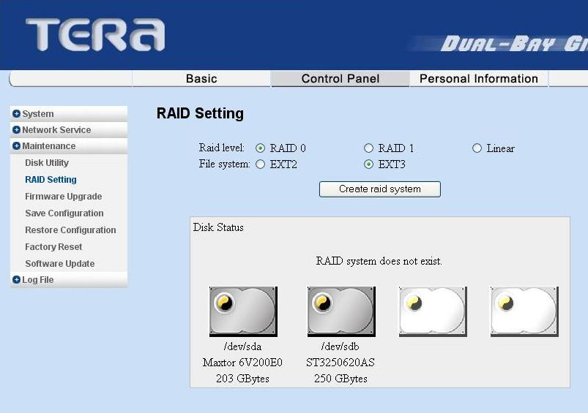

Step2. If you choose the RAID 0 and EXT3 format and click the create button, then process bar will start up.
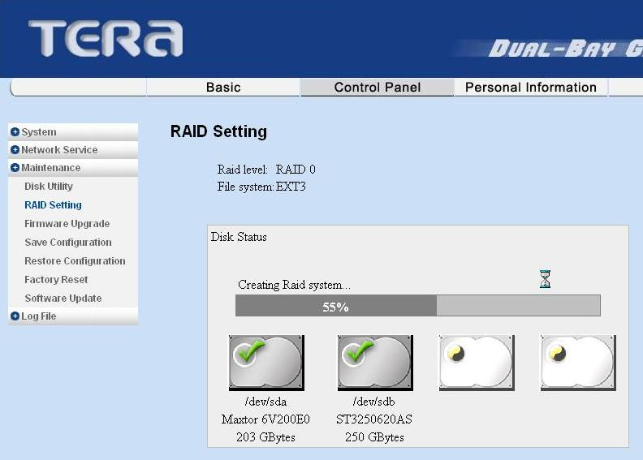

Step3. After the creation, the ME580GNS will reboot again.

7.6.3 Firmware Upgrade
This function shows “Current Firmware Version”, you can download the latest firmware version to the system by input the correct path and the upgrade file name in the “Upgrade File” Box, or browse by Windows explorer. When you upgrade the firmware, all the network services will stop.

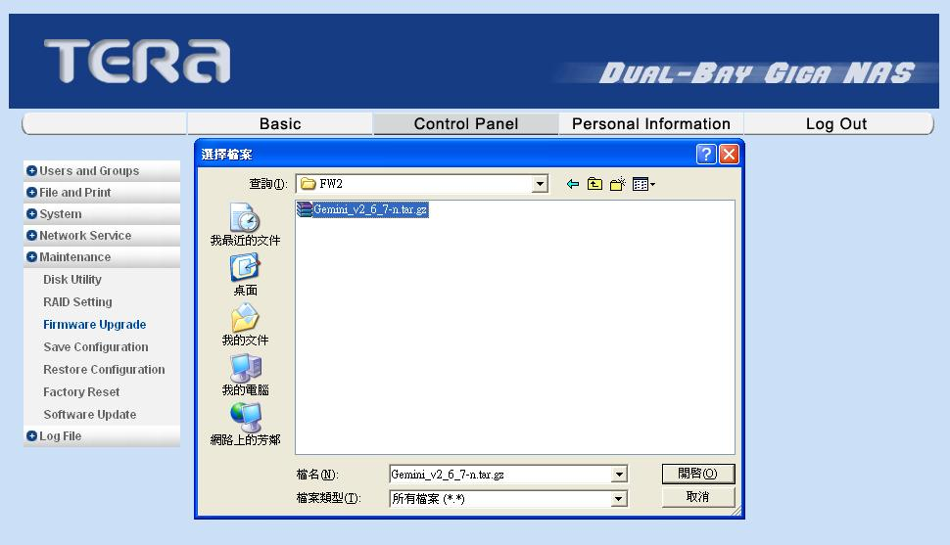

After the upgrade completed the system will auto re-boot again.

7.6.4 Save Configuration
When you setup all configuration and you would like to backup the setting, this function can backup current system configuration to a local disk, save it in a specified file name. The default file name is “config.tar”.

7.6.5 Restore Configuration
When the system configuration is destroyed, lost, or incorrectly changed, you can restore system configuration that you saved by using “Save Configuration” function. Select a configuration file by windows file explorer, and press “Restore” button to restore the system configuration by using the selected configuration file.

7.6.6 Factory Reset
Factory Reset function resets the system configuration to factory default configuration. When this button is executed, all users, networking, and other configuration information will be lost.

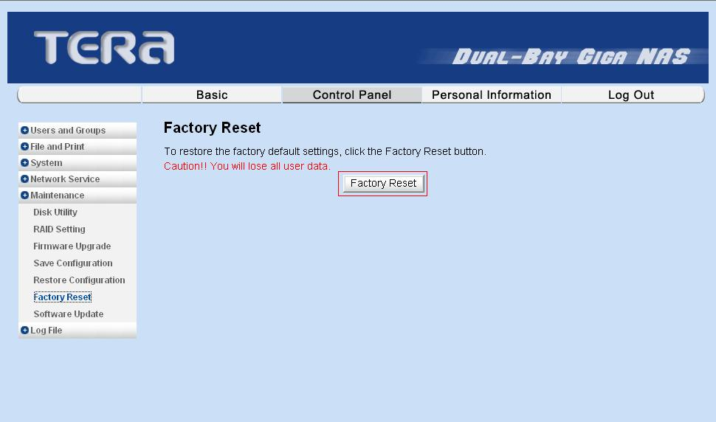

7.6.7 Software Update
ME580GN-S provides some other applications for using like BT Download and Media Server. If you would like to use these applications, you should install them. There is a button “Installed Software” could show the application that you have installed and you also can uninstall the application here.
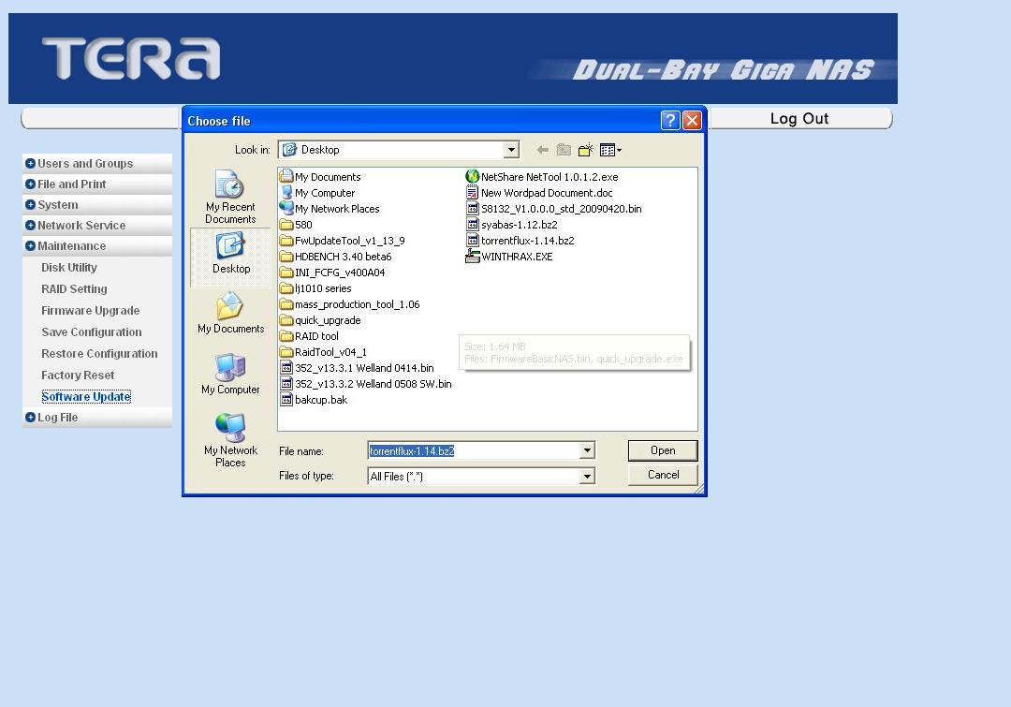

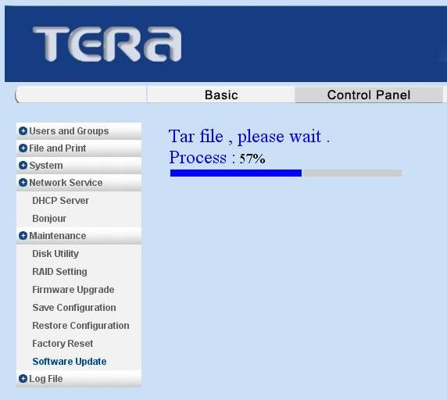

After the installation completed the system will auto re-boot again.

7.7 Log File
There are five sections are included in Log File. There are “Samba Log”, “FTP Log”, “DHCP Server Log”, “System Log”, and “Administration Log”. These log files could help you to trace the task that you have done. And you also can click the Clear button to erase the log files.

8. How To Reset The Configuration Setting
This Reset function will recover all the settings to the factory default. Reset items is the same as factory reset, please refer to 6.6.5 Factory Reset. And please prepare a needle firstly.
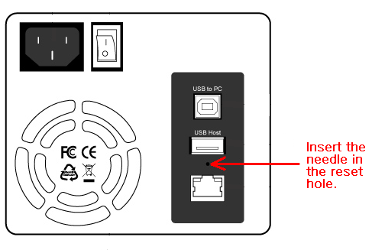
Step1. Use a needle to push the reset button.
Step2. Push the reset button about 5 seconds, and power off/on the NAS to finish the reset.

9. How To Replace A Faulty Hard Drive
This function should be used when you setup the hard disk format in RAID1. When there is a hard drive occurs error, you will get the warning voice from the ME580GN-S and the error icon from the RAID Setting.
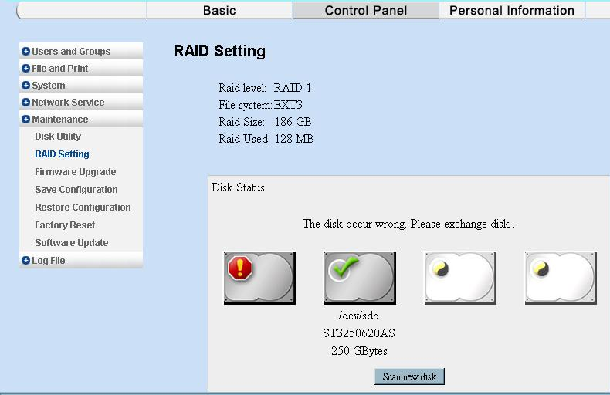

Step1. Power down the ME580GN-S, and then take out the hard drive and replace a new one. And then put in the ME580GN-S.
Step2. Power on the ME580GN-S, the RAID 1 will start to rebuild the system automatically. But the finishing time depends on the HDD capacity
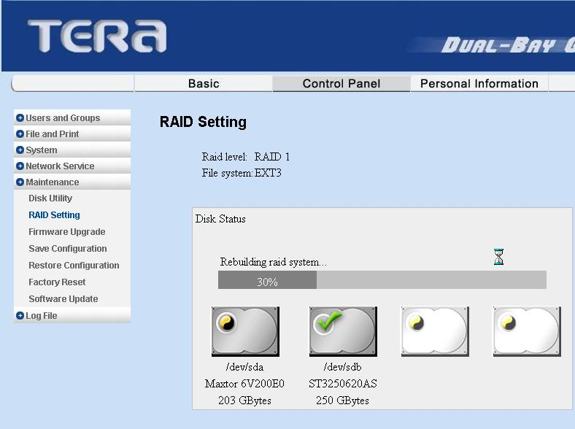

Step3. After the rebuilding task is finished, the system will reboot again.

10. FAQ

1. Does the ME580GN-S have compatibility issue with any 3.5 inches SATA HDD？
A: It might have compatibility issues with some old type 3.5 inches SATA HDDs , but it works fine with new type 3.5 inches SATA I/II HDDs.

2. Does ME580GN-S support the other explorers, like Firefox, KKMAN etc.?
A: Yes, please execute the NAS Tracker Program to find the IP address, and fill in the specific IP address to other explorers.

3. Does ME580GN-S support Bonjour (iTunes)?
A: Yes, it supports this function.

4. What can I do if I forgot the administrator’s password?
A: The only way is to reset the device. Please find the rear panel of ME580GN-S. Please refer to 8. How To Reset The Configuration Setting

5. What can I do if I forget the user’s password?
A: Please assign a new password in SAMBA user account.

6. Why can’t I create new SMB user?
A: Please check that your hard disk has been formatted. Please refer to 4.3 Format the hard disk for the first time using.

7. Why does the BitTorrent download fail when I uploaded it to Bit Torrent lists?
A: Please go to the official & authorial webpage to get the Bit Torrent list. ME580GN-S can’t promise to recognize all BitTorrent lists if the torrent resources are not properly organized.

8. Does ME580GN-S support the UPnP function?
A: Yes. ME580GN-S supports UPnP function. In Vista system, UPnP is an enabled default setting. In Windows2000/XP system, you need to manually enable UPnP function.

9. Does ME580GN-S support DMA/DLNA protocol or media devices, such as PS3, Xbox360 ?
A: Yes. ME580GN-S supports mentioned items.

10. What situation that I need to use “Reboot” function?
A: Sometimes when network traffic or system is heavy loading, you can use this function to “soft-restart” you system. All settings will be recovered few minutes later.

11. Can I use the ME580GN-S as USB storage after using it as NAS storage?
A: Yes. You can use it exactly and you will see the folders of Public, BT, SMB user and FTP account that created by the NAS. Moreover, you also can execute the files from these folders. But, be careful that the format of the hard drive is FAT32 or NTFS can be access only.

12. What is the first priority when connecting the USB and LAN cable to NAS?
A: The first priority is USB and then LAN. When using NAS disk as a network NAS, please do not plug the USB cable.

13. Can I hot-swap the HDD when ME580GN-S was working on RAID mode?
A: No, please turn off ME580GN-S first, and then take out the HDD you prefer.

