Multi Function Cable Tester

User Manual English

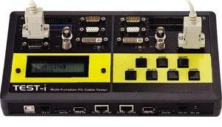

LINDY No. 43019

www.lindy.com

Introduction

Thank you for purchasing the LINDY Multi Function Cable Tester. This specially designed cable tester; tests and analyses a comprehensive range of PC connector types and the most commonly used cables. It not only tests each pins connection to identify open circuits, short circuits and mis-wires, it also shows pin to pin connectivity, and can record up to a 100 test results. The crucial data collected can be saved and uploaded to a PC via USB for analysis.
With an integrated LCD Display (with back light function), you can clearly determine the cable pin wiring easily and efficiently.

Features

- Identify open wires, short wires, and mis-wires
- Supports 18 types of PC cable connector
- 100 Test results can be saved and transferred to the PC via USB
- Alphanumeric LCD with back light function
- Low voltage indicator
- Connectors: IDC40, IDC34, DVI29, HDB15M/F, DB9M/F, COAX, BNC, RJ11, RJ45, 1394-6P, 1394-4P, SATA, USB(A/B), HDMI, RCA
- Power: DC 9V Battery or DC 9V 150mA power jack (adapter not included)

Button definition

ON/OFF Press the ON/OFF button to power the tester and back light on or off

UP/DOWN Press the UP/DOWN button to select the function

SAVE Press the SAVE button to save the test results

DELETE Press the DELETE button to delete the record of any status/condition

BACK Press the BACK button to return to the main menu

ENTER Press the ENTER button to run the selected function

Getting Started

1. Push the ON/OFF button to power “on” the tester. A beep sound will indicate that the tester is working. The LCD will show the following message:

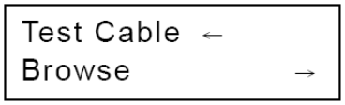

2. In operating mode, you can press the ON/OFF button to switch the LCD’s back light to “on” or ”off”. By holding the ON/OFF button, the LCD will display the following message:
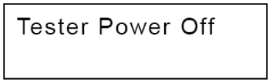

The tester will power “off” when you release the button.

3. In operating mode, you can hold the DOWN button for 5 seconds to activate the "Alarm" function, after the display shows "Alarm OFF(or ON)" you can press ENTER to turn on/off the alarm and press the DOWN button to go back to back to previous menu.
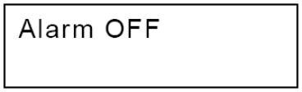

4. In operating mode, press the UP or DOWN button to select the desired mode: “Test Cable” for line testing, “Browse” to review the saved data, or “Fast Test” to quickly test a cable and then press ENTER to confirm the desired selection.
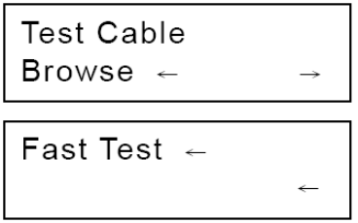

Testing a Cable

1. Use the UP or DOWN button to select the number of pins for the cable you want to test, then press ENTER to start the test.
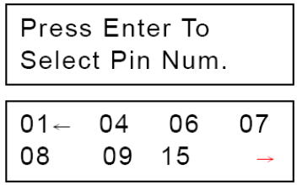

2. When the test is done, the LCD will display the pin-pin connectivity. The results will be displayed as the following:
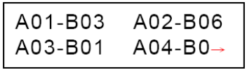

3. If no cable is connected to the tester, it will “beep” twice and display the message “Empty”:
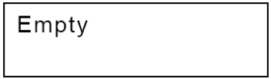

You can select UP and DOWN to check each pin to pin test result, or press ENTER to select pin number. By pressing BACK you return to main menu.

Fast Test

The cable tester also provides a “Fast Test” function to test a large numbers of cables in a short time:

1. Select “Fast Test” in the main menu then press ENTER.
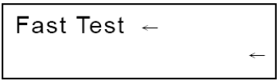

2. Select “Define Standard” to create the standard pin to pin connectivity as the model, the standard will be compared to the other cables and determine whether the cable is good or bad. The default setting is to save automatically.
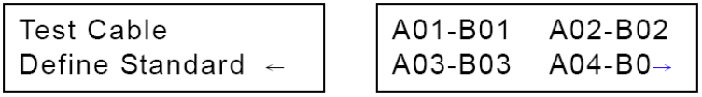

3. When the standard is defined, select “Test Cable” to check cable’s status. If the cable’s pin to pin connectivity matches the standard, the cable tester will show “OK” and will display the detailed pin to pin connectivity. If not, the cable tester will show “Error” and also display the cable’s detailed information to make it easy to identify the problem.

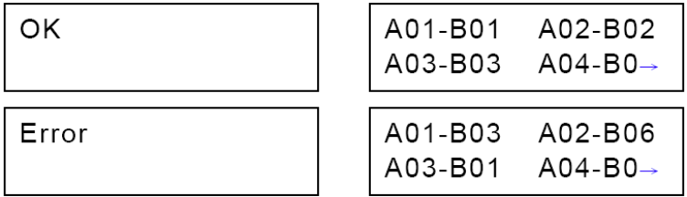

Save, Delete, Browse and Upload the Record

1. Press the SAVE button to save the last test result (saving sequence is from 1 to 100).The LCD Display will show:


2. By pressing the DELETE button, the tester will display two options in the menu: “Delete All” or “Delete One” Press the UP or DOWN button for the desired selection and confirm your selection by pressing ENTER
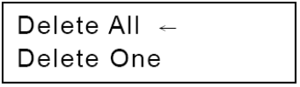

3. If deleting a specific record, select “Delete One” and press the UP or DOWN button to choose the record you want to delete, then press ENTER to delete this record (Note: by pressing ENTER again, it will delete the next record saved). Press BACK to return to the main menu.

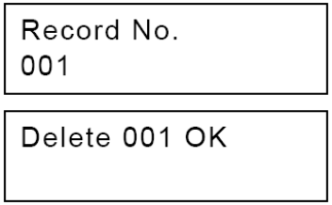

4. To review a saved record, select the “Browse” function in the main menu. Press the UP or DOWN button to select the desired record and press ENTER to display the data.
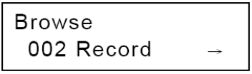

How to upload data to your PC

Make sure you have downloaded and installed the latest version of the software from the LINDY website (http://www.lindy.com) To use this software you must have access to an application that supports csv files.

1. Connect USB cable between tester and computer, then power on the tester. Ignore the first window that appears
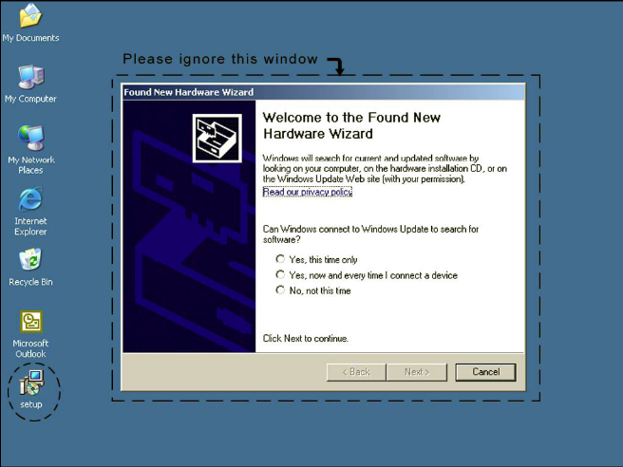

2. Double click the Setup.exe program from where you saved it and install the application
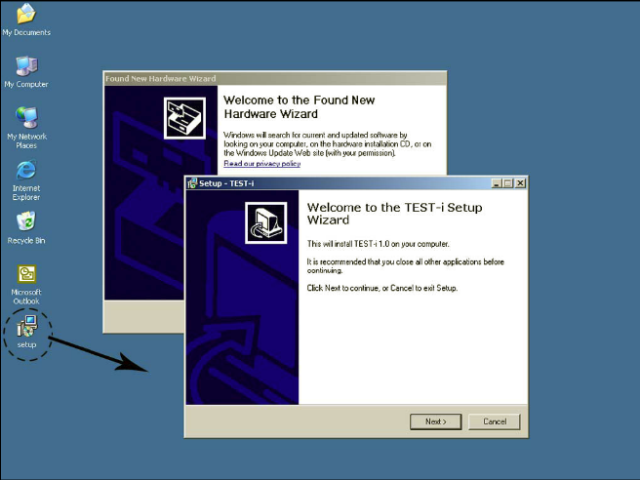

3. Ignore the warning and press “Continue Anyway”
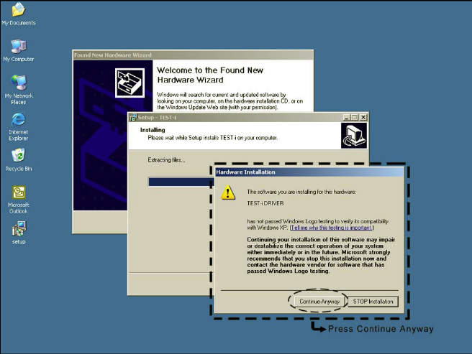

4. Complete the installation by selecting “Finish”

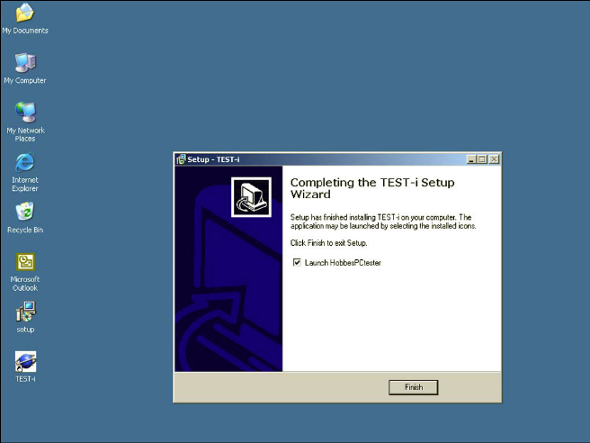

5. Run the TEST-I program by double clicking the icon
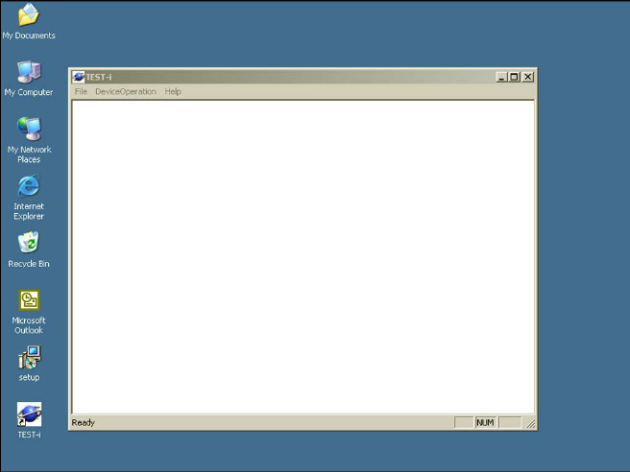

6. To upload data from the cable tester, select “device operation” from the toolbar and “get records”
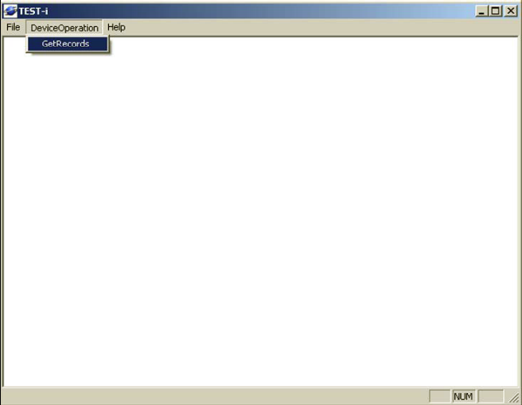

7. On the next screen, click “update list” to renew the interface list then select “GetRecords” to download the data from the cable tester to the PC
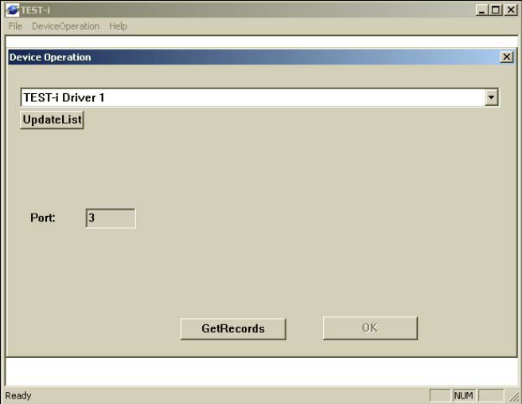

8. When the button “GetRecords” is selected, the tester’s LCD monitor will display the following message:
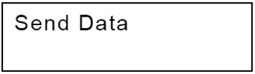

Once the data has been transferred you should see the screen below on the PC
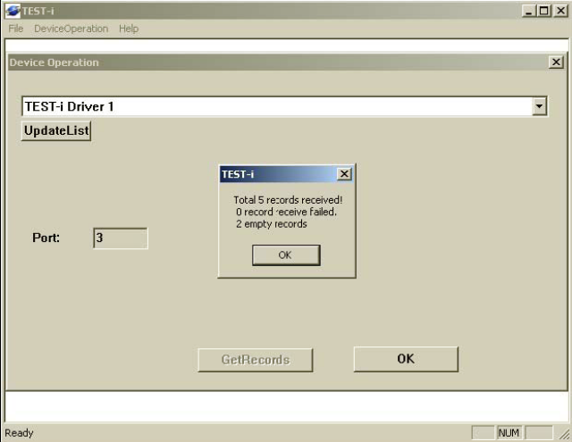

9. Press “OK” to close this message window, and then press “OK” to view the records

When all the data has been uploaded, the tester’s LCD will display the following message:

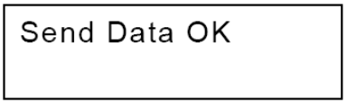

10.The PC will display the records in pin to pin connective sequence
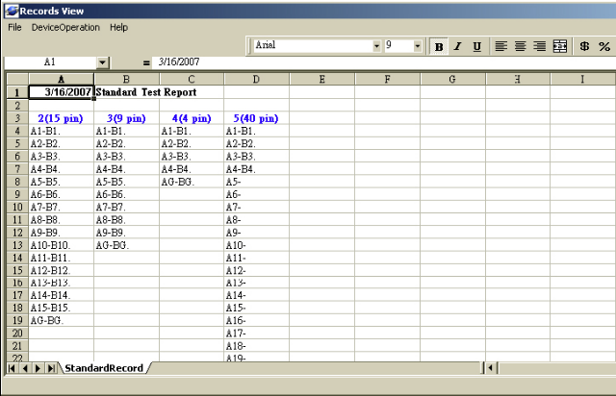

Record View definition:

(X) (Y) shows the number of the pin:
A(X) － : The Cable is broken (no connection)
A(X) － B(X) : Correct connection (Cable is good)
A(X) － A(Y) : The Connection is shorted (Cable defective)
B(X) － B(Y) : The Connection is shorted (Cable defective)
A(X) － B(Y) : The connection is miss-wired (Cable defective)

CE Statement
This device complies with the European Regulations for Electromagnetic Compatibility (EMC) of the European Union and it is equipped with the CE mark. This unit has to be used with high quality shielded connection cables. Only if these high quality shielded cables are used it can be sure that the EMC compatibility is not adversely influenced.

FCC Statement
Shielded cables must be used with this equipment to maintain compliance with radio frequency energy emission regulations and ensure a suitably high level of immunity to electromagnetic disturbances.

FCC Warning
This equipment has been tested and found to comply with the limits for a Class B Digital device, pursuant to part 15 of the FCC Rules. These limits are designed to provide reasonable protection against harmful interference in a residential installation. This equipment generates, uses, and can radiate radio frequency energy and, if not installed and used in accordance with the instructions, may cause harmful interference to radio communications. However, there is no guarantee that interference will not occur in a particular installation. If this equipment does cause harmful interference to radio or television reception, which can be determined by turning the equipment off and on, the user is encouraged to try to correct the interference by one or more of the following measures:
- Reorient or relocate the receiving antenna
- Increase the separation between the equipment and receiver
- Connect the equipment into an outlet on a circuit different from that to which the receiver is connected
- Consult the dealer or an experienced technician for help
You are cautioned that changes or modifications not expressly approved by the party responsible for compliance could void your authority to operate the equipment.


WEEE (Waste of Electrical and Electronic Equipment),
Recycling of Electronic Products

United Kingdom
In 2006 the European Union introduced regulations (WEEE) for the collection and recycling of all waste electrical and electronic equipment. It is no longer allowable to simply throw away electrical and electronic equipment. Instead, these products must enter the recycling process.
Each individual EU member state has implemented the WEEE regulations into national law in slightly different ways. Please follow your national law when you want to dispose of any electrical or electronic products.

More details can be obtained from your national WEEE recycling agency.

Germany / Deutschland
Die Europäische Union hat mit der WEEE Direktive umfassende Regelungen für die Verschrottung und das Recycling von Elektro- und Elektronikprodukten geschaffen. Diese wurden von der Bundesregierung im Elektro- und Elektronikgerätegesetz – ElektroG in deutsches Recht umgesetzt.
Dieses Gesetz verbietet vom 24.März 2006 an das Entsorgen von entsprechenden, auch alten, Elektro- und Elektronikgeräten über die Hausmülltonne! Diese Geräte müssen den lokalen Sammelsystemen bzw. örtlichen Sammelstellen zugeführt werden! Dort werden sie kostenlos entgegen genommen. Die Kosten für den weiteren Recyclingprozess übernimmt die Gesamtheit der Gerätehersteller.

France
En 2006, l'union Européenne a introduit la nouvelle réglementation (WEEE) pour le recyclage de tout équipement électrique et électronique.
Chaque Etat membre de l’ Union Européenne a mis en application la nouvelle réglementation WEEE de manières légèrement différentes. Veuillez suivre le décret d’application correspondant à l’élimination des déchets électriques ou électroniques de votre pays.

Italy
Nel 2006 l’unione europea ha introdotto regolamentazioni (WEEE) per la raccolta e il riciclo di apparecchi elettrici ed elettronici. Non è più consentito semplicemente gettare queste apparecchiature, devono essere riciclate.
Ogni stato membro dell’ EU ha tramutato le direttive WEEE in leggi statali in varie misure. Fare riferimento alle leggi del proprio Stato quando si dispone di un apparecchio elettrico o elettronico.
Per ulteriori dettagli fare riferimento alla direttiva WEEE sul riciclaggio del proprio Stato.

LINDY No. 43019


1st Edition July 2007

www.lindy.com

